- We estimate that the UK neutral interest rate – the rate consistent with monetary policy that is neither stimulative nor restrictive – has risen recently to just below 3%. We project it is now set to fall back to a long-run nominal neutral rate of around 2% by 2030.
- The main reason behind the recent increase in the nominal neutral rate and the predicted decline is inflation expectations. Our analysis suggests that as inflation expectations normalise, the structural forces that have pushed rates down since 1980 will reassert themselves. This is likely to prevent a return to the much higher rates in the decades preceding the global financial crisis.
- Stripping out inflation expectations, the real neutral rate has risen far more modestly in recent years. We expect the UK's weak demographic and productivity prospects to keep the neutral real rate at historically low levels for the foreseeable future.
- Neutral rate estimates are inherently uncertain, especially for small open economies such as the UK. Still, our approach provides a framework that can inform our view of the path for long-run interest rates, and our scenario analysis offers a useful gauge of the risks around our estimates.
The Bank of England's Monetary Policy Committee has signalled that there's a good chance the first interest rate cut of this cycle will take place in the next few months. This raises the key question of where Bank Rate might settle in the long-term when the MPC's rate-cutting cycle ends.
To answer this question, we have extended our previous analysis that estimated the long-run neutral interest rate – the rate where monetary policy is neither stimulatory nor restrictive – for the US and eurozone to the UK. Estimates of the neutral rate are inherently uncertain, especially for small open economies such as the UK. Still, we think our approach offers a consistent and helpful framework to assess the forces shaping the neutral rate. Our findings suggest that the nominal neutral rate has risen since the pandemic, but not excessively so, and that part of the recent rise is likely to unwind over time (Chart 1).
Chart 1: Our long-run neutral rate estimates suggest Bank Rate may end the decade around 2%
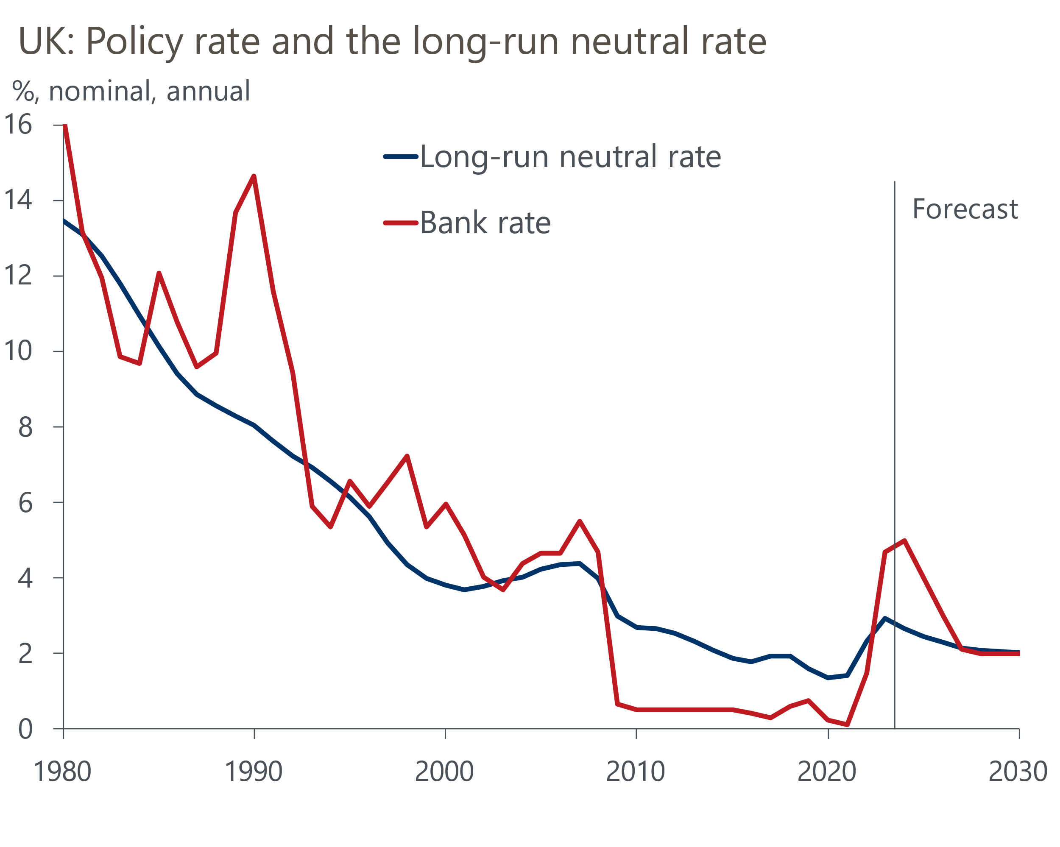
Source: Oxford Economics, Haver Analytics

Our approach to modelling neutral rates has built on and extended the influential work of Eggertsson et al. (2019). Their research introduced New-Keynesian (NK) frictions to an overlapping generations (OLG) model. The OLG part captures how the lifecycle savings and consumption behaviour of an ageing population, together with slowing productivity growth, lead to subdued private demand and an increase in the supply of savings. This pushes down the neutral rate that equilibrates supply and demand in the capital market. The NK frictions allow the policy rate to deviate from the neutral rate for prolonged periods.
We extended this work to include net foreign assets, net migration, increases in retirement age, and the stock of securities held by central banks. More details on our approach are available in the online appendix attached to this publication. This contains a basic description of the model, as well as documentation on our forecasts, scenarios, and estimated parameters. A formal discussion of the model can be found in our white paper.
The neutral rate cannot be observed directly, so estimates are always subject to considerable uncertainty. But estimating this model for the UK is arguably more challenging than for large economies such as the US or eurozone, due to the greater impact of external developments outside of changes in net foreign assets or net migration. Meanwhile, large UK-specific structural shifts over the past 50 years suggest domestic developments may have played more of a role too.

Higher inflation expectations are behind the recent rise in the nominal neutral rate
The main reason why the nominal neutral rate has risen in recent years and is projected to fall over the next few years is long-run inflation expectations. Inflation increased dramatically in 2021 and 2022 due to the pandemic, Russia's invasion of Ukraine, and a surge in pay growth. The resulting rise in inflation expectations lifted the nominal neutral rate, which our estimates suggest is now slightly below 3%.
With Bank Rate currently at 5.25%, it is well above our estimate of the long-run nominal neutral rate. This means the BoE's policy stance is quite restrictive at the moment, corroborating the language introduced in the MPC's recent policy statements which noted that policy was at a restrictive level, and it would remain restrictive even if Bank Rate were to be lowered a bit.
With most of the impacts of recent supply shocks having dissipated and CPI inflation now close to the BoE's 2% target, inflation expectations have fallen back significantly. As inflation expectations continue to normalise, we think the secular forces that drove interest rates down in previous decades will firmly reassert themselves. Therefore, we anticipate the long-run nominal neutral rate ending this decade at around the 2% mark.
However, our scenarios, discussed below, highlight that the risks to our baseline are currently skewed to the upside. What's more, in the upcoming rate cutting cycle, already-low inflation and recovering growth prospects suggest the BoE might not lower Bank Rate all the way to a level that we estimate would represent a neutral policy stance.
Stripping out inflation expectations, the long-run real neutral rate is arguably the more important concept. According to our analysis, the real neutral rate may edge upward in the near-term, similar to our findings for the US and the eurozone. However, the bigger picture is that we expect the neutral real rate to remain close to zero for the foreseeable future (Chart 2).
Chart 2: Our modelling suggests the long-run real rate will remain low
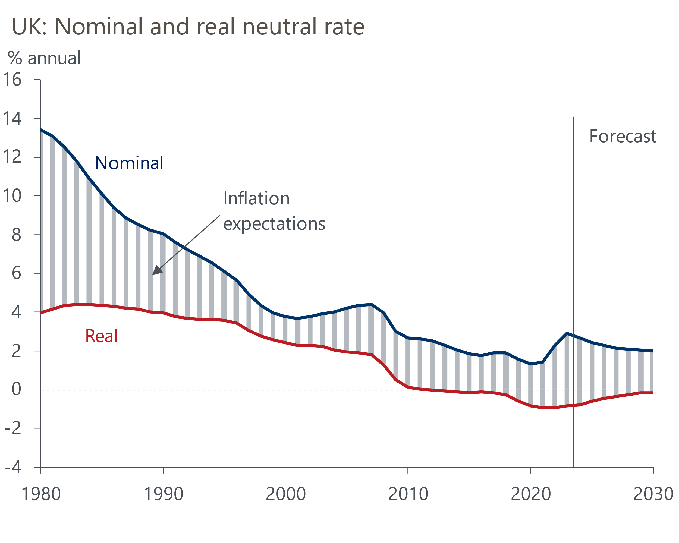
Source: Oxford Economics

The contributions of secular forces
In contrast to most other models, ours can quantify the separate contributions of major secular forces to the change in the real neutral rate. We recognise that for the UK – a small open economy compared to the US or eurozone – a number of factors may be missing. Still, we account for nine forces to guide our estimates. This is more than in any other study that we are aware of (Table 1).
Intuitively, each of these forces shifts the aggregate supply of, or aggregate demand for, capital, though often in non-linear and time-varying ways. When the supply of capital rises relative to demand, the neutral rate falls, and vice versa. We explained the various economic channels in our most recent US briefing on this topic and in the online appendix to this report. Here, we summarise the main findings.
Rising government debt has been the main structural force pulling up the neutral rate. Following large upward shifts in the wake of the global financial crisis and the pandemic, public sector net debt (excluding financial interventions) has increased to roughly 100% of GDP. The rising supply of gilts corresponds to an increase in the demand for capital by the government, hence putting upward pressure on the neutral rate. Simultaneously, higher government spending supports aggregate demand and economic growth, further bolstering the neutral rate. Looking ahead, we don’t expect government debt to fall materially (as a % of GDP), so this factor is unlikely to drag on the real neutral rate in the future (Table 1).
According to our estimates, demographic change is the main reason for the low neutral rate, both in the past and in the future (Chart 3). Improvements in longevity have outpaced increases in retirement age in recent decades, and based on current policy this is set to continue. As a result, households need to accumulate more retirement savings during working life, raising the supply of capital. Meanwhile, a falling birth rate means that, with a delay of about 20 to 30 years, there are fewer young households taking up loans, so the demand for capital falls. In addition, fewer young people entering the labour force means lower workforce growth, which implies slower potential growth. Therefore, both lower fertility and rising longevity each drag on the neutral real rate. Net inward migration, consisting of relatively young people, offsets some of the impact of falling fertility rates, but has a much smaller impact on the neutral rate.
With legislated increases to the statutory state pension age limited, and the lagged impact of lower birthrates on the labour force still to be fully realised, the contribution from demographic change is likely to weigh on the neutral rate significantly in the coming years.
Chart 3: Demographic change is the primary reason for our low neutral rate estimate
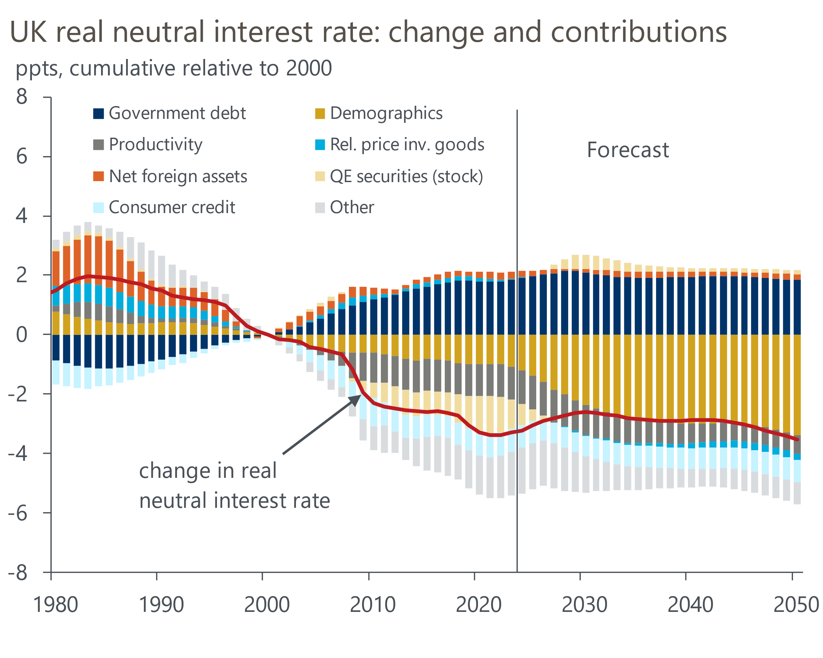
Source: Oxford Economics
The UK's productivity growth has dropped in the last two decades and barely recovered since the global financial crisis. Weaker trend total factor productivity growth depresses the neutral rate because it lowers potential output growth and investment returns, while also lowering wage growth and the borrowing capacity of young households. Looking ahead, we see scope for a partial recovery in productivity growth, partly because it's unlikely we'll see a repeat of the succession of negative shocks (global financial crisis, Brexit, and the pandemic) that have weighed on UK productivity growth so heavily over the last 15 years. Productivity growth could also be further boosted by developments in artificial intelligence and investment in technologies to tackle climate change, but we're cautious about the size and timing of the productivity gains from these sources. So we think improvements in productivity growth may only offer limited support to the neutral rate in the future.
Table 1: We see some scope for a trend reversal until 2030, but secular stagnation thereafter
Decomposition of secular forces
 | 1980–2000 | 2000–2023 | 2023–2030 | 2030–2050
Change in real neutral rate (ppts) | -1.5 | -3.3 | 0.7 | -0.9
Contribution (ppts)
Government debt | 0.9 | 1.8 | 0.2 | -0.2
Demographic change | -0.8 | -1.1 | -1.3 | -1.0
ㅤㅤㅤFertility rate & net migration | ㅤㅤㅤ0.4 | ㅤㅤㅤ-1.3 | ㅤㅤㅤ-0.7 | ㅤㅤㅤ-0.7
ㅤㅤㅤLongevity | ㅤㅤㅤ-1.2 | ㅤㅤㅤ0.2 | ㅤㅤㅤ-0.6 | ㅤㅤㅤ-0.3
Productivity | -0.2 | -1.1 | 0.1 | 0.4
Net foreign assets | -1.2 | 0.2 | -0.1 | 0.1
QE securities (stock) | -0.1 | -1.0 | 1.5 | -0.4
Relative price of investment | -0.6 | 0.0 | -0.1 | -0.2
Consumer credit | 0.8 | -0.8 | 0.1 | -0.1
Other | -0.2 | -1.4 | 0.2 | 0.5
ㅤㅤㅤLabour share | ㅤㅤㅤ-0.1 | ㅤㅤㅤ-0.2 | ㅤㅤㅤ0.0 | ㅤㅤㅤ0.0
ㅤㅤㅤInteractions | ㅤㅤㅤ-0.2 | ㅤㅤㅤ-1.2 | ㅤㅤㅤ0.3 | ㅤㅤㅤ0.5
Source: Oxford Economics
In the 1980s, the UK undertook significant liberalisation of its financial system, which eased credit constraints and lowered credit spreads. This shift in the demand for loans had an upward effect on the neutral rate. Given our model uses a measure of unsecured consumer credit, it misses the upward impact of the large increase in mortgage credit. The upward trend in consumer credit peaked in the mid-2000s, and the global financial crisis caused a sharp widening in credit spreads, which weighed on the demand for loans and dragged on the neutral rate by the end of the decade.
Due to its magnitude and extended duration, the BoE's stock of government bonds under its quantitative easing (QE) programs may be considered a new structural force, which in our framework directly offsets some of the impact of rising government debt. In line with recent studies, our results suggest that the purchase of government bonds depressed the long-run neutral rate slightly between 2009 and 2022, and that this is now starting to reverse following the start of the BoE's quantitative tightening. However, the question of whether central bank holdings of government debt should be considered in this framework is debated.

What it would take to escape low interest rates
What would it take for the neutral real rate to permanently return to the higher real rates of the past, say 1%? To answer this, we computed counterfactuals in which we varied one secular force at a time, keeping all others fixed at their 2023 values (all else being equal). The key takeaway from the results – shown in Table 2 – is how unlikely it is that we'll see much higher interest rates.
For example, for a 1% real neutral rate, trend TFP growth would need to rise from the current 0.1% y/y to 1.4%, a value last reached in the 1980s. The changes required in net foreign assets or the fertility rate look even less likely. Given its trajectory in recent decades, probably the most plausible lever would be outstanding government debt, which would need to rise from 100% of GDP to 146% to achieve a neutral real rate of 1%. But that's still a long way from our prediction of 83% in 2050.
Table 2: Level needed for each variable (all others equal) to raise the real neutral rate in 2023
 | 2023 | Level needed (c.p.) for r* of 0% and 1%
Real neutral interest rate | -0.8% | 0.0% | 1.0%
Government debt (% GDP)* | 100% | 120% | 146%
Productivity growth (y/y)** | 0.1% | 0.7% | 1.4%
Net foreign assets (% GDP)** | -13% | 12% | 40%
Fertility rate (children / woman) | 1.6 | 2.1 | 2.5
Source: Oxford Economics. c.p. = ceteris paribus. *Excl. pension claims. **Smoothed with HP-filter or moving average.

Our scenario analysis suggests the real neutral rate is likely to remain low
Our estimate of the UK neutral rate is below those from other organisations, such as the BoE's Market Participants' Survey and the IMF. Therefore, we have designed a series of upside scenarios to see how our estimate of the neutral rate would evolve under different assumptions. Here, we change the future path of one secular force, while the paths for the remaining forces remain as in the baseline. This section summarises our findings – further details can be found in our online appendix.
In our highest upside scenario, we replaced our baseline government debt assumption with the OBR's scenario under additional departmental spending pressures, as laid out in its 2023 Fiscal Risks and Sustainability publication. Here, the OBR assumes the departmental expenditure limit rises by around 1.5% of GDP from 2029 with no corresponding tax increases, meaning there is a permanently lower primary balance. This increases outstanding government debt to around 160% of GDP by 2050, nearly double what we currently forecast in our baseline. In this scenario, the real neutral rate would rise to 1.6% by 2050 (Chart 4), substantially higher than the baseline, but still below levels in the early 2000s.
Chart 4: Alternative scenarios point to a relatively high bar for a stronger real neutral rate
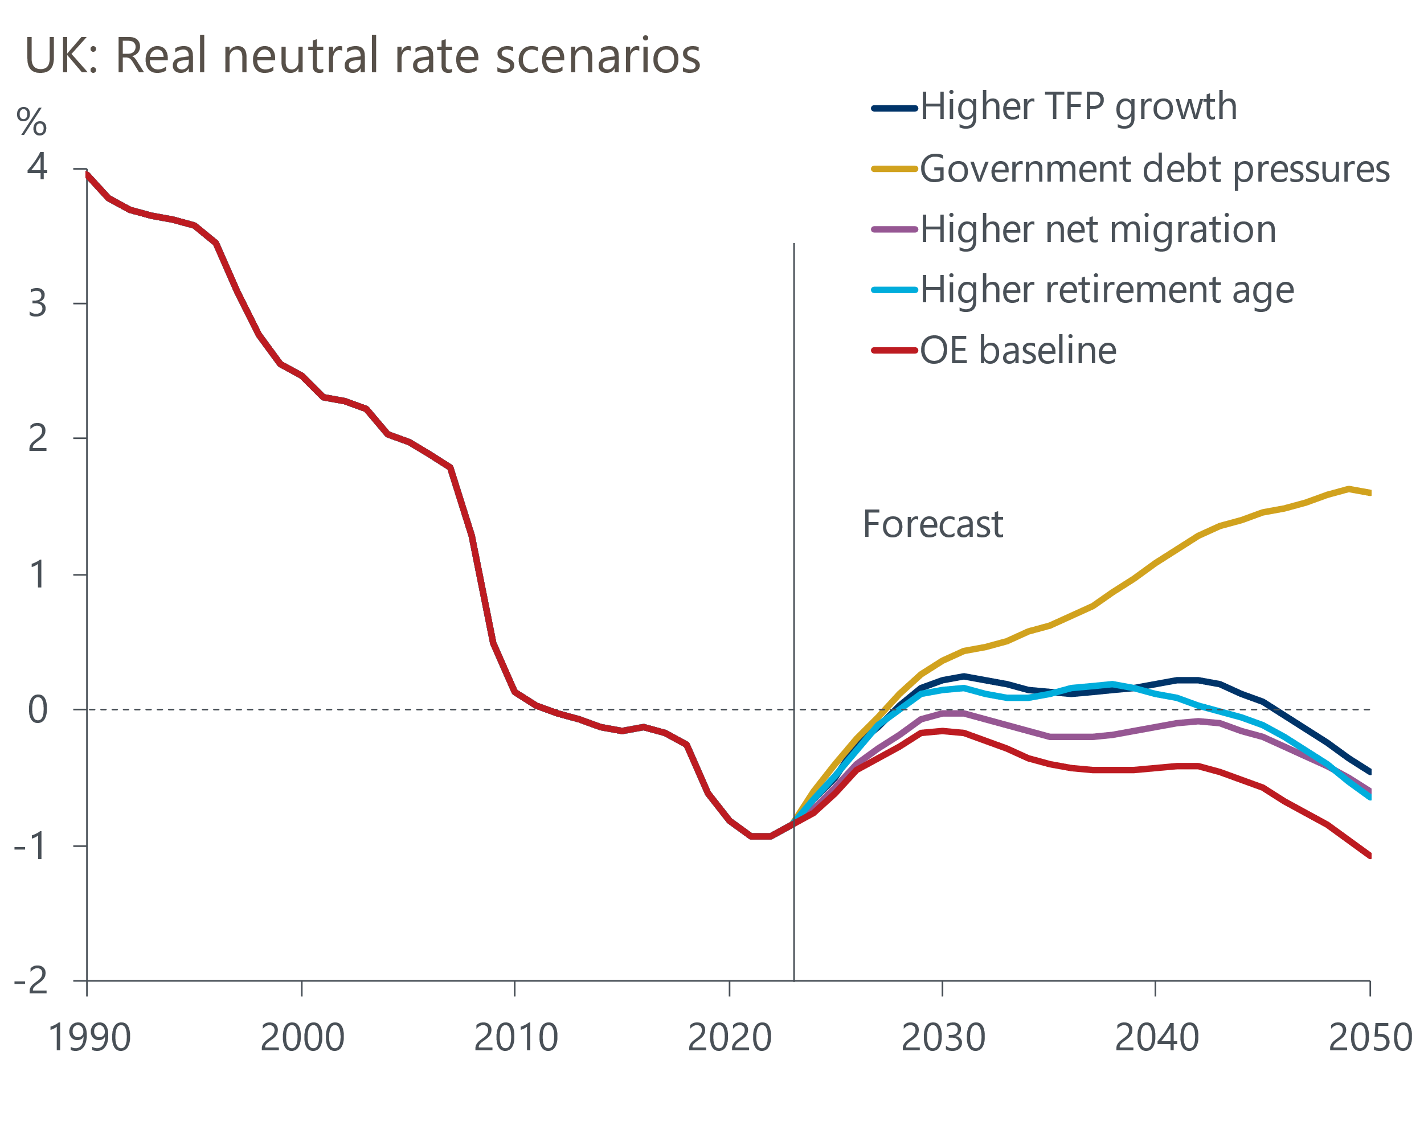
Source: Oxford Economics
Our remaining three scenarios involve less extreme assumptions and show limited increases in the real neutral rate. Our baseline uses the ONS' low migration variant, which assumes net inflows of 253,000 people a year over the medium-term. Replacing this with the ONS' high migration variant, which anticipates inflows settling at 379,000 people a year, has a small upward effect on the neutral rate. Since net migration is a flow variable, the impact gradually builds over time.
Our next scenario assumes trend TFP growth returns to 1% y/y in the medium-term, its average growth rate in the 1980-2000 period, instead of our baseline forecast of roughly 0.5% y/y. Our findings suggest this would only raise the real neutral rate by 0.6ppts by 2050.
In our higher retirement age scenario, we assume an additional single-year increase to the state pension age between 2036 and 2038. This is on top of the two single-year increases to the statutory state pension age that have been legislated for and that are included in our baseline. Our results suggest this would raise the real neutral rate slightly to -0.6% by 2050 from -1.1% in our baseline. The economic intuition behind this is that a higher retirement age offsets the effect of greater longevity explained earlier.

Estimates of the neutral rate are highly uncertain
Neutral rate estimates are always highly uncertain. We think this is especially true for countries like the UK that are smaller than the US or eurozone and are relatively sensitive to international developments. Moreover, the UK has undergone significant structural change in the past 50 years, some of which can be difficult to account for. That said, projections for the most important secular force – demographic change – are relatively reliable even over longer periods, as those born in the recent past determine the labour force and number of retirees far into the future.

References
Eggertsson, Gauti B., Neil R. Mehrotra, and Jacob A. Robbins. 2019. ‘A Model of Secular Stagnation: Theory and Quantitative Evaluation’. American Economic Journal: Macroeconomics 11 (1): 1–48. https://www.aeaweb.org/articles?id=10.1257/mac.20170367.

